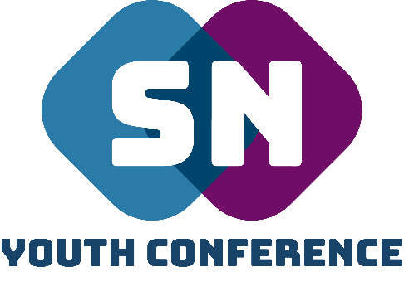
Financial Policy

Thank you for requesting the SNYC team to come and speak at your church service / event. We would never refuse to help a church that could not afford to make any financial contribution towards the cost of this ministry event and so please be assured that, if you are in this situation, this booking will be fulfilled.
However, if you are able, we would ask that you please cover the SNYC’s team travel expenses at 45p per mile (from Woking, GU22 9BX) and consider giving a ministry gift towards the continued work of SNYC – New Life Church Woking
Any payment can be made by bank transfer to the following account:

Sort Code: 090154
Account No: 45496088
Reference: SNYCTEAM

Or alternatively by giving the team a cheque on the day of the event made out to ‘New Life Church Woking.’

If you have any further questions please do not hesitate to contact me: snyc@gmail.com

Big Blessings,

Supernatural Youth Conference Team

