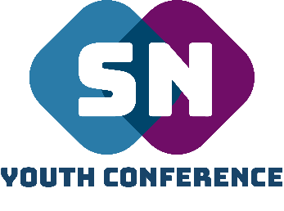
SNYC TEAM BOOKING Requesting
Thank you for requesting the Supernatural Youth Conference Team to come and speak.
We kindly ask that you fill in all the sections below to request your booking.
(Once the booking request has been completed and sent, we will get back to you on whether we can attend or not. We hope & pray that we can)
What would you like to book the team for? (Please mark with an X)

Event/Conference:

Church Weekend Away:

Training/Equipping Day:

Youth Group/Ministry:

Sunday Morning:
(Please be aware NLC Woking is our main priority on Sunday mornings so we are very limited on those days)

Organisation/
Church/Event Name

Contact Name

Email Address

Telephone Number

Location the team to would need to attend, including post code:

How many people will be in attendance? (Approx)

What is the age range of those attending?

Timings you would need the team to arrive & be with you

Would you like us to provide some form of worship?

Are you able to provide overnight accommodation if required?

Any other information you feel would be helpful?

Please return this form by email on:
snycuk@gmail.com
Thank you.

